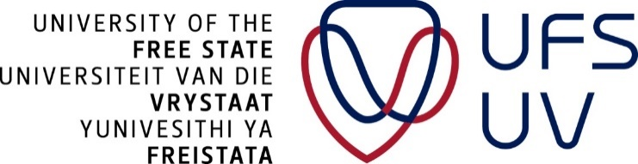

**Postgraduate school**

**Conventional and unconventional student-supervisor relationship**

**PRESENTER**: Dr Fumane Khanare

**DATES:** 17 February 2019

**TIME:** 12:00-15:00

**VENUE:** Johannes brill, room 19

**TARGET AUDIENCE:** UFS staff, Postgraduate students, Postdoc fellows

**Workshop objectives:**

1. To create awareness of the conventional and non-conventional supervisory relationship;
2. To explore the potential usefulness of non-conventional relationship in the research supervision;
3. To afford participants an opportunity to explore how to enhance research supervision relationship by means of an asset-based approach.

**Profile of the presenter:**

Dr Fumane Portia Khanare is the acting head of school and a senior lecturer in the School of Education Studies at the Faculty of Education, University of the Free State. Her research focuses on care and support for teaching and learning. With particularly emphasis on using participatory visual arts-based methodologies and asset-mapping, she strives for enabling learning environments and transformative learning. Furthermore, she serves as a book review editor for an Online Journal of Educational Research for Social Change and an associate editor for an African Journal of Educational Research in Rural Contexts. She holds a PhD from Nelson Mandela University and Master’s degree in Educational Psychology (cum laude) from the University of KwaZulu-Natal.

***If you are interested in attending this presentation, booking is essential as seating is limited. This workshop is free of charge. To RSVP for the session, please click on the link:*** <https://events.ufs.ac.za/e/conventional>

***If you can’t access the link, please contact Tshepiso Molaba*** [***molabatp@ufs.ac.za***](mailto:molabatp@ufs.ac.za)***.***

N.B:

* RSVP’s close four days before the workshop
* No attendance will be allowed without an RSVP
* Failure to attend after an RSVP will attract a penalty of R500 charged to the individual concerned.