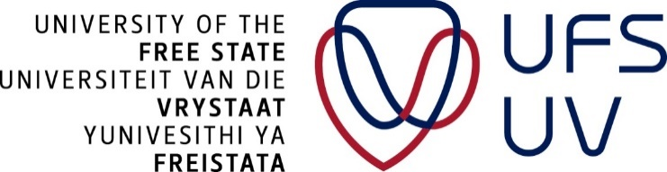

Postgraduate school

Thesis Examination workshop

DATES: 7 February 2020
TIME: 08:45-16:00
VENUE: Johannes brill, room 19
PRESENTER: Prof Judith Bruce
TARGET AUDIENCE: UFS staff, postdoc fellows

Thesis Examination workshop

- Nature of the thesis examination process
  - What do you look at?
  - What do you start with?
  - What are the most important issues to consider for:
i. A research report/mini- dissertation
ii. Dissertation
iii. Thesis
- General criteria for thesis examination
  - Examining a qualitative research report/thesis
  - Examining a quantitative research report/thesis
- Types of reports requested (format for narrative and marks)
- How does an examiner’s report look like? What should be included?
- What does the following outcomes mean?
· Pass with no corrections
· Pass with minor corrections
· Pass with major corrections
· Re-examination
· Fail
- Time frames from receiving a thesis until submission of a report
- Arbitration processes – when should this be considered?

Profile of the presenter:

Professor Judith Bruce is an academic and researcher, with more than 25 years’ experience in higher education. She obtained her PhD in 2003 and has supervised more than 48 postgraduates to completion; she has examined more than 30 research reports, dissertation and theses across a range of health science disciplines. Prof Bruce has published widely in accredited, peer-reviewed journals, is the author of two textbooks and has contributed to more than 20 book chapters. She has a keen interest in developing and promoting education and research scholarship in nursing locally, and on the African continent, through the work of NEPAD and Sigma Theta Tau International. She remains active in local chapter work and as a philanthropist and mentor, actively supports the development of future scholars and nurse leaders. Prof Bruce is a Fellow of the Academy of Nursing of South Africa and serves on the Health Portfolio of the Academy of Science of South Africa. She is currently the Head of the School of Therapeutic Sciences at Wits University.

If you are interested in attending, booking is essential as seating is limited. This workshop is free of charge. To RSVP for the session, please click on the link: https://events.ufs.ac.za/e/examination
If you can’t access the link, please contact Tshepiso Molaba molabatp@ufs.ac.za.
N.B:
- No attendance will be allowed without an RSVP
- Failure to attend after an RSVP will attract a penalty of R500 charged to the individual concerned.
WEBINAR OPTION
- Off-campus, QwaQwa campus and south campus based postgraduate students and staff can access the presentation via a webinar
- Should you be interested in attending via a webinar, please register and then choose the webinar session on the online RSVP form

