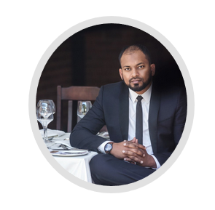

Muhammad Ali
Managing Director and Lead Auditor
Project leader & expert in ISO 9001, ISO 14001, OSHAS 18001/ISO 45001, ISO 27001, ISO 22000, 20000-1, ISO 31000, and ISO 50001.
Muhammad is a qualified Industrial and Systems Engineer with a Master’s Degree from the University of Pretoria. He is currently registered with the University of Pretoria to complete his Doctorate in Industrial and Systems Engineering, with a topic relating to ISO Management Systems. He is a Safety, Health, Environmental, Risk and Quality (SHERQ) Registered Lead Auditor who assists the SABS with certification audits on ISO 9001, ISO 14001, ISO 27001, ISO 20 000-1 and ISO 50 001. Muhammad has wide-ranging experience in the public sector, telecommunications, automotive, construction, engineering, manufacturing and various service sectors. He has assisted over 90 clients in the past 11 years as a consultant and is the Managing Director of WWISE. WWISE has a 100% record in certifying clients to any ISO standard with various certification bodies.
Prior to WWISE, Muhammad had worked at the Automotive Leather Company (ALC) as a Quality Engineer in the production and quality control of the manufacturing of Mercedes Benz E-Class Seats (W211) from 2006 – 2007. Thereafter Muhammad had branched into the nuclear industry working on the Pebble Bed Modular Reactor (PBMR) project assisting Hi-Tech Select in documenting processes, creating efficiency models and following various International Standard Compliance mechanisms. The South African Quality Institute (SAQI) in 2008/9 had identified the potential of Muhammad’s knowledge on ISO Management Systems and ability to train and motivate people. SAQI had then asked Muhammad to start his own company and granted him two projects. To assist the Diplomatic Academy from the Department of Foreign Affairs to become ISO 9001:2008 Certified and train Acelor Mittal Engineers on the course of Certified Quality Technicians. The success has lead Muhammad to then grow his business by word of mouth and quality proficiencies to be where is now, with employing over 30 staff and assisting over 90 clients globally in ISO Certifications.
Muhammad has been supported by Small Enterprises Development Agency Science and Technology Programme (SEDA STP) to assist SMME’s in creating structures and systems using various ISO standards to create assurance of local and international clients.

